Application for admission to nursery school
A. Child’s data
First name:
Surname:
Surname at birth:
Date of birth:
Place of birth:
Permanent Residence
Street and number:
Postcode:
Municipality/City:
State:
Address of the child’s habitual residence (if not at the child’s permanent address)¹⁾
Street and number::
Postcode:
Municipality/CityState:
Birth reg.numer:
Nationality:
Ethnicity:
Primary native language:
Other native language:
B. Name of the nursery school to which I/we request admission of my/our childľa
C. Personal data of the child’s parents / guardians or the representative of the facility

PARENT / GUARDIAN 1
Name:
Surname:
Title:
Birth reg.numeber, or date of birth if foreigner:
Permanent Residence:
Street and number:
Postcode:
Municipality/City:
Štate:
State:
Contact for communication purpose
Correspondence address⁾
Street and Number:
Municipality / City:
Číslo elektronickej schránky (v tvare E000000000):
Phone numeber:
Email:
Relationship with the child Father
Mother
other
Please, specify which⁶⁾:
1
2
3
4
5
6
) Vypĺňa sa v prípade, ak sa miesto, kde sa dieťa obvykle zdržiava, nezhoduje s adresou trvalého pobytu.
) Primárny materinský jazyk je jazyk, ktorý si dieťa najlepšie osvojilo v ranom detstve a najčastejšie ním komunikuje v prostredí, v ktorom žije. Primárny materinský jazyk nemusí byť jazykom matky dieťaťa.
) Iný materinský jazyk je jazyk, ktorý dieťa používa v prostredí, v ktorom žije, popri primárnom materinskom jazyku.
) Uvedie sa kontakt, ktorý preferuje zákonný zástupca na účely komunikácie. Jeden údaj je povinný; vypĺňa sa aj vtedy, ak zákonný zástupca nepoužíva elektronickú schránku.
) Uvádza sa vtedy, ak sa korešpondenčná adresa nezhoduje s adresou bydliska.
) Napr.: Iná fyzická osoba než zákonný zástupca, ktorá má dieťa zverené do osobnej starostlivosti alebo do pestúnskej starostlivosti na základe rozhodnutia súdu, alebo zástupca zariadenia, v ktorom sa vykonáva ústavná
starostlivosť, neodkladné opatrenie alebo výchovné opatrenie na základe rozhodnutia súdu.
219 MŠVVaM SR / od 01. 01. 2026
Prihláška na vzdelávanie v materskej škole
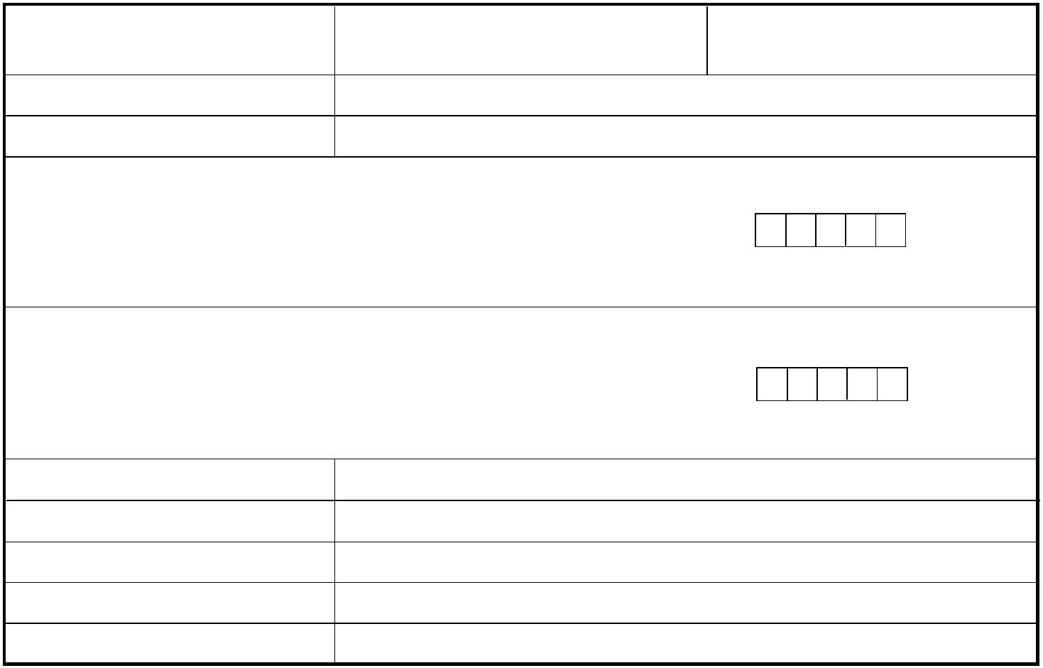
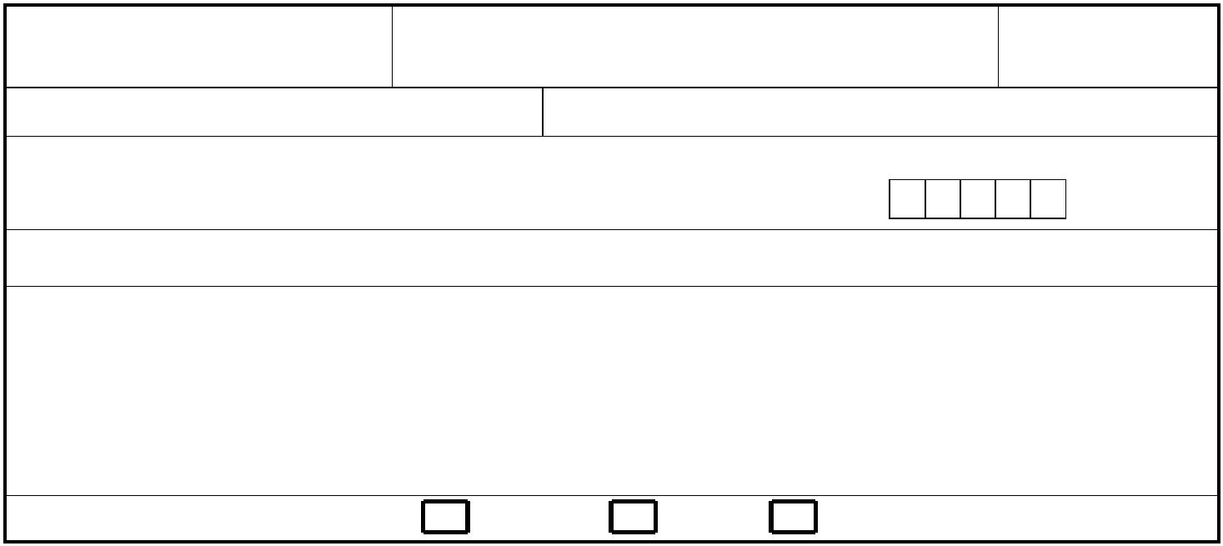

to T

PARENT / GUARDIAN 2
Name:
Surname:
Title:
Birth reg.numeber, or date of birth if foreigner:

Permanent Residence
Street and Number:
Postcode:
Municipality/ City:
State:
State:
Contact for communication purpose
Correspondence address⁾
Street and Number:
Municipality / City.
Číslo elektronickej schránky (v tvare E000000000):
Telephone:
Email:
Relationship with the child Father
Mother
Other
Please, specify, which⁾:
FACILITY REPRESENTATIVE
Name:
Surname:
Title:
Name of facility:
CRN:
Adress of the facility
Street and Number:
Postcode:
Municipality/ City:
State
Číslo elektronickej schránky (v tvare E000000000):
Telephone:
Email:
D. Additional information
I am applying for admission of a child for:
half-day education
full time education
I request for school canteen meals
Child with a disability:
Child with a talent:
yes
yes
yes
no
no
no
Requested date of the child’s admission to the nursery school:: .......................
I request the provision of pre-primary education to the child in ⁷)
Slovak language
the language of the national minority concerned⁸) .....................................................
another language⁸) .................................................................................................
Notice⁹⁾:
7) Uveďte len jednu možnosť.
8) Uveďte konkrétny jazyk.
9) Zákonný zástupca/zástupca zariadenia môže uviesť doplňujúce informácie týkajúce sa dieťaťa (napr. zdravotné obmedzenia, návyky dieťaťa alebo iné informácie rozhodujúce pre vzdelávanie dieťaťa), príp. informáciu
o tom, či dieťa: 1. v aktuálnom čase navštevuje inú materskú školu; 2. žiada o prijatie aj do inej/iných materských škôl; 3. má v materskej škole staršieho súrodenca atď.
219 MŠVVaM SR / od 01. 01. 2026
Prihláška na vzdelávanie v materskej škole
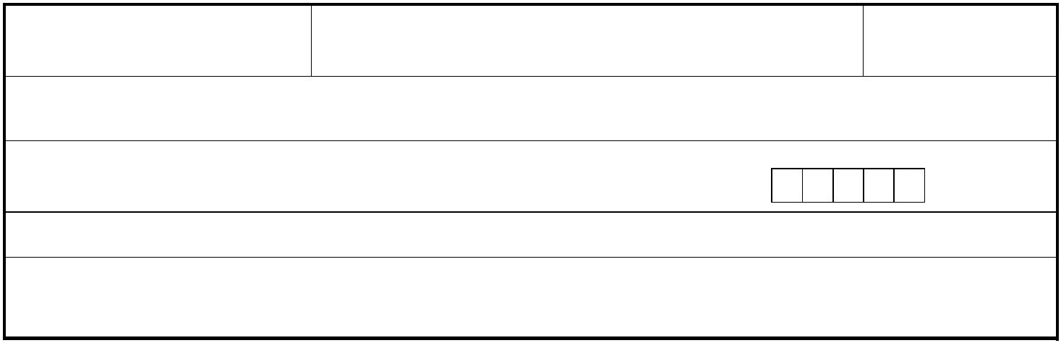


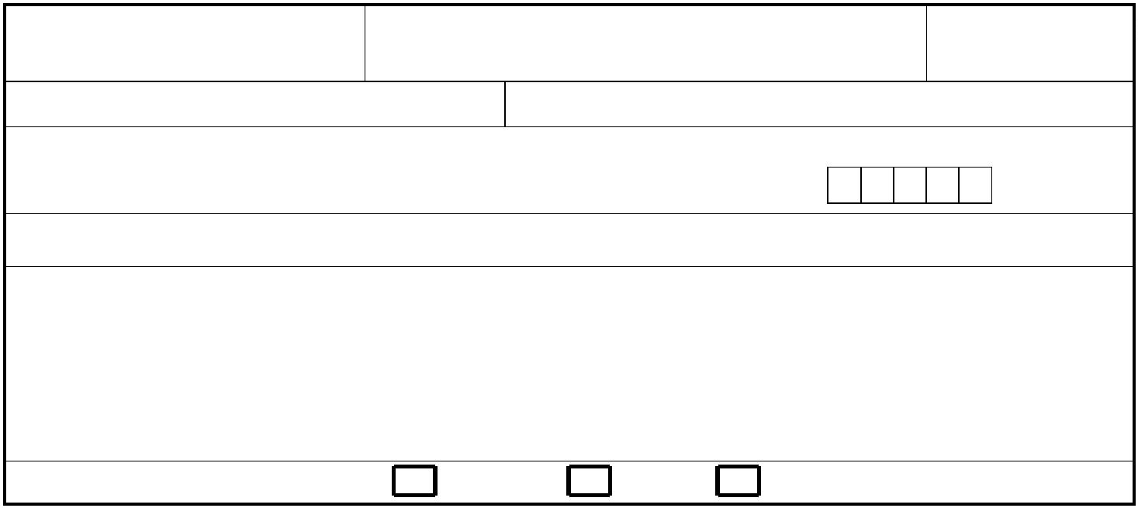

E. Privacy Notice
The personal data provided in this application is collected and processed in accordance with Section 11(6) of Act No. 245/2008 on Education and Training (School Act) and on the Amendment and Supplementation to Certain Acts, as amended, for the purposes of education and training and activities outside of school hours.
In.................................................... date .............................................
In .................................................... date .............................................
In.................................................... date .............................................
....................................................
signature of parent / guardian 1
...................................................
signature of parent/guardian 2
...................................................
signature of the representative of the facility
Notes:
1.
The application must be accompanied by a certificate of medical fitness of the child issued by a pediatrician,
including information on the child’s ´mandatory vaccinations.
2
.
If the admission concerns a child with a disability, the application must be accompanied by:
a certificate of medical fitness of the child issued by a pediatrician, including information on mandatory vaccinations,
a report from a diagnostic assessment issued by a counselling and prevention facility, and
a recommendation from the pediatrician.
-
-
-
3.
If the admission concerns a child with a talent, the application must be accompanied by:
-
a certificate of medical fitness of the child, including information on the child’s mandatory vaccinations, and
a report from a diagnostic assessment issued by a counselling and prevention facility.
-

-

